👉

SHINU RATHOD

company : Zidio development

Digit Recognition Project

Deep Learning using CNN

## 

## **1. Project Overview**

The **Digit Recognition** project aims to accurately identify handwritten digits using the MNIST dataset and Convolutional Neural Networks (CNNs). The project includes data preprocessing, building and training a CNN model, and deploying it using Streamlit for user interaction.

## **Tools and Technologies**

* **Programming Language**: Python
* **Libraries**: TensorFlow, Keras, Pandas, Numpy, Matplotlib
* **Deployment**: Streamlit, MySQL

## **2. Objectives**

* Develop a CNN-based model to classify handwritten digits (0-9).
* Achieve high accuracy in digit recognition by optimizing model performance.
* Deploy the model using a user-friendly interface for practical usage.

### 2.**1. Business Understanding**

#### **Business Problem**

Manual processing of handwritten documents poses significant challenges for industries like banking, postal services, and retail, where handwritten digits must be frequently read and interpreted. This manual approach results in:

* **High labor costs** due to extensive human involvement.
* **Delays in processing time**, slowing down operations.
* **Errors in data interpretation**, leading to inaccuracies.
* **Limited scalability**, making it difficult to handle high-volume processing efficiently.

These limitations hinder operational efficiency and increase overall costs.

#### **Business Solution**

A **digit recognition system powered by deep learning (CNNs)** offers a robust solution by:

* Automating the reading and digitization of handwritten inputs.
* Enhancing accuracy and reducing human error in data processing.
* Accelerating processing times to meet high-volume demands.
* Significantly lowering operational costs and improving scalability.

This system provides industries with a faster, more reliable, and cost-effective approach to handling handwritten digit data.

### **3.** Dataset

#### **Dataset Overview**

The **MNIST dataset** is a widely recognized benchmark for handwritten digit recognition tasks. It comprises **70,000 grayscale images of handwritten digits**, each labeled with a corresponding digit (0–9).

#### **Key Features of the MNIST Dataset**:

* **Image Dimensions**: 28x28 pixels (Black & White).
* **Number of Classes**: 10 (digits 0 through 9).
* **Total Images**: 70,000 (60,000 training and 10,000 testing samples).

#### **Use Case**

The dataset is ideal for training and testing machine learning models for digit recognition, providing a solid foundation for implementing a robust deep-learning solution to classify handwritten digits efficiently.

## **4. Methodology**

### **4.1 Data Preprocessing**

* Normalized pixel values to a range of [0, 1].
* Reshaped data to match CNN input requirements (28x28x1).

### **4.2 Model Architecture**

* **Base Model**: Convolutional Neural Network (CNN)
* **Layers**:
  + Convolutional layers with ReLU activation
  + MaxPooling layers for dimensionality reduction
  + Fully connected dense layers
* **Activation Function**: Softmax for multi-class classification

### **4.3 Training**

* **Loss Function**: Categorical Crossentropy
* **Optimizer**: Adam
* **Metrics**: Accuracy
* **Epochs**: 20
* **Batch Size**: 64

## **6. Results**

* Achieved **98%** accuracy on the MNIST test set.
* Efficiently processed large volumes of handwritten digit data.

## **7. Deployment**

* **Tool Used**: Streamlit
* **Features**:
  + Upload CSV/Excel files for predictions.
  + Displays results with an interactive and visually appealing interface.

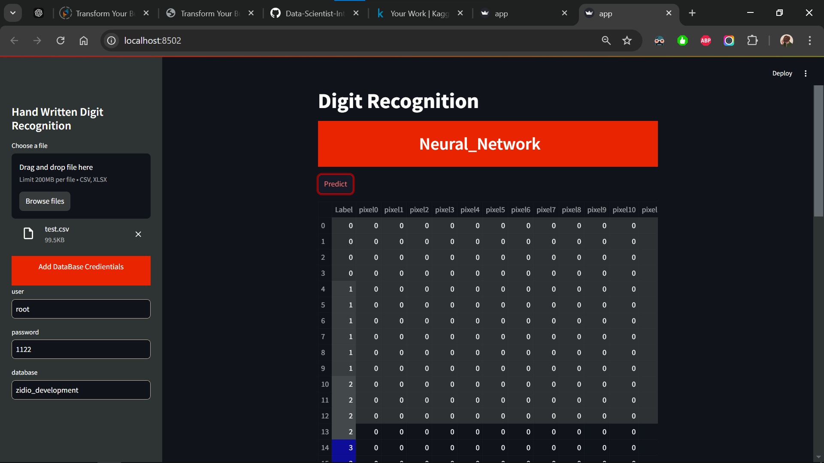

## **7. Key Challenges**

* Optimizing the model to balance accuracy and computational efficiency.
* Handling data inconsistencies during preprocessing.

## **8. Future Scope**

* Extend the model to recognize digits in noisy or real-world datasets.
* Integrate the system with Optical Character Recognition (OCR) applications.

**9. How to Run the Project**

• Clone the repository from [GitHub](https://github.com/SHINU4RATHOD/SHINU4RATHOD-Data-Scientist-Intern-Zidio-Development).

• Install required libraries: Requiremnt.ext - • pip install -r requirements.txt

• Load the Streamlit application: • streamlit run app.py

• Upload a file (CSV/Excel) containing digit data for predictions.

## **10. Acknowledgments**

Special thanks to **Zidio Development** for providing this opportunity and guidance throughout the project.

## **11. GitHub Repository**

For the complete code and details, visit: [GitHub Link](https://github.com/SHINU4RATHOD/SHINU4RATHOD-Data-Scientist-Intern-Zidio-Development)

Thank you🥰